**Kingsport’s ShowTime 1988 – 2010 & 2017**

**Student Show Choir Auditions with Musical Theater Classes**

**Auditions Will Be Held**

**Saturday, May 20th**

Grades K – 3rd 10:00 a.m.

Grades 4th – 8th 11:00 a.m.

Grades 9th – 12th 12:00 Noon

**Wednesday May 24 & Tuesday, May 30**

Grades K – 3rd 4:00 p.m.

Grades 4th – 8th 5:00 p.m.

Grades 9th – 12th 6:00 p.m.

*Or by appointment*

Audition Location:

Centre for Performing Arts

727 North Eastman Road, Kingsport, TN 37664

**Show Choir With Musical Theater Classes for Students**

It is our goal to provide a summer Show Choir experience with a wonderful community-involvement experience for all three sections of our student show choirs. We sing pop, show tunes, rock and roll, gospel, country, and patriotic music from the early 1900s to contemporary pop tunes. The show choirs will sing and dance – musical theater style as part of Kingsport’s ShowTime 2017 Centennial performances. The students must attend the musical-theater classes and all rehearsals to participate in the shows. There are fees for the classes, but not for the show or the costumes. More information with a complete schedule is available on our website: [www.KingsportShowTime.com](http://www.KingsportShowTime.com) and on Facebook Kingsport’s Showtime.

Classes for both Teenage and Student ShowChoirs and Children’s cast will meet two or three a week for the month of June. The Boys’ Class will meet once per week. The length of class times are designed to be fun for the students, accomplish our goals, and complete the dance routines before the rehearsals begin at Eastman.

We are looking forward to a great summer of classes, rehearsals, and shows!

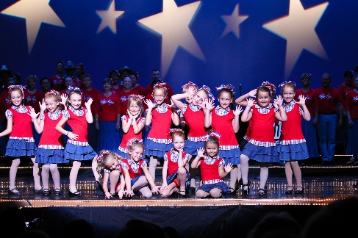

**Kingsport’s ShowTime 2017**

**Centennial Shows**

**Celebrating the “Spirit of Kingsport”**

Friday, July 7 @ 7:30 p.m.

Saturday, July 8 @ 7:30 p.m.

Sunday, July 9 @ 2:30 p.m.

Tickets Available June 1st

Eastman Employee Center

[www.KingsportShowTime.com](http://www.KingsportShowTime.com)

Reserved Sections $25 & $15 General Admission (Balcony) $8

**Thank You To Our Sponsors -**

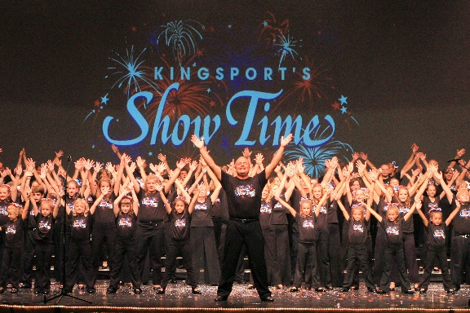**Eastman Chemical Company**

**Food City**

**WJHL -TV**

**For More Information Contact:**

**Louise Dickson, Ed. D. 423.534.8874**

Producer, Co-Director, Choreographer

[LouiseBaileyDickson@gmail.com](mailto:LouiseBaileyDickson@gmail.com)

**Clarkston Parker**

Vocal Director, Co-Director, Musical Arranger

[Clark08@charter.net](mailto:Clark08@charter.net)

Join us for our 25th production and be a part of a Kingsport musical tradition !